**GRANDMA’S HOUSE OF HOPE**  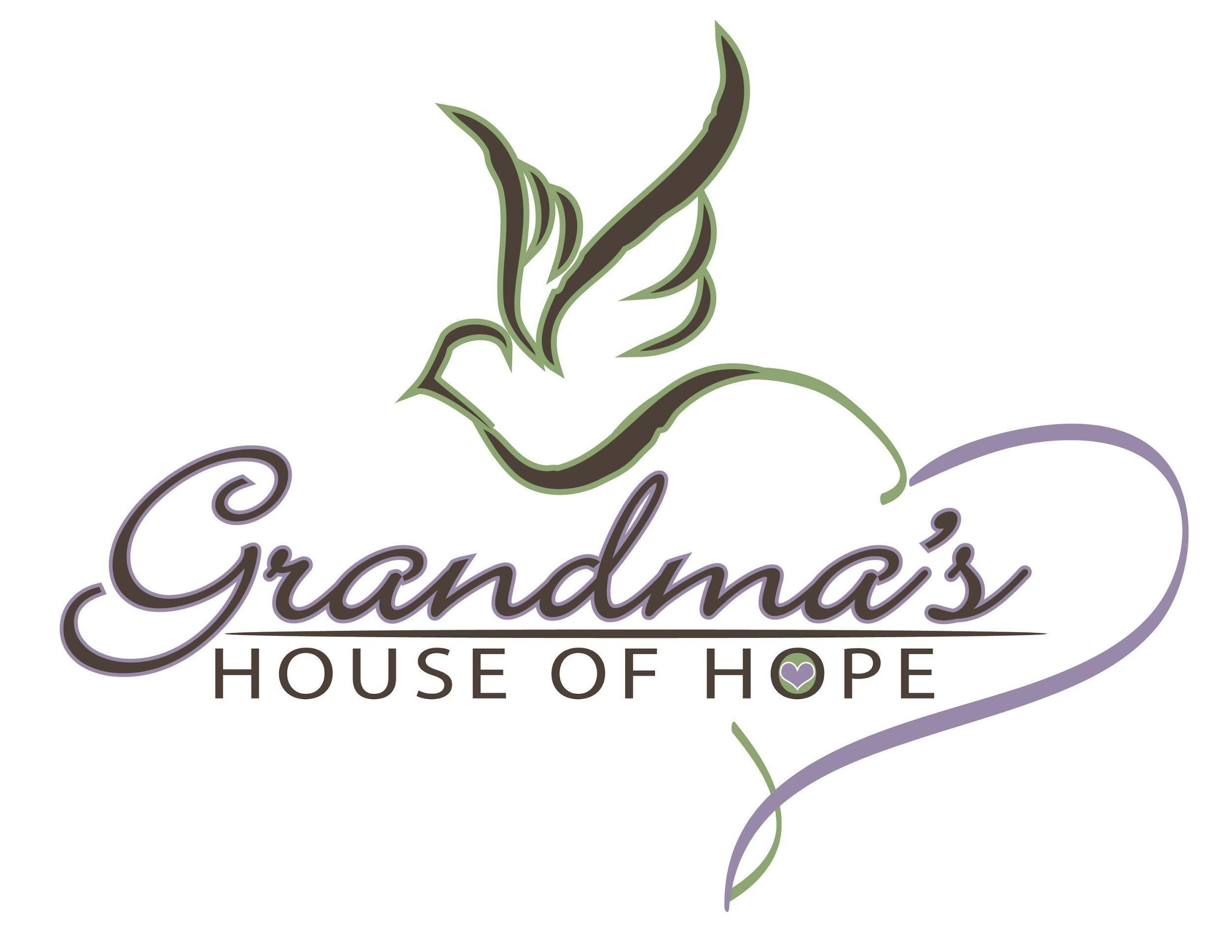

Substance Use Disorder Counselor I

**Job Title:** Substance Use Disorder Counselor - I

**Reports To:** Housing Program Manager

**FLSA Status:** Non-exempt

**Supervises:** N/A

**Employment Status:** Full-time (40 hours/week)

**Salary Range:** $26-$28/hour

**Schedule**: Monday - Friday

**Organization:** Grandma’s House of Hope (GHH) empowers the invisible populations of Orange County by serving those who truly slip between the cracks of other programs. Founded in 2004, GHH fills gaps in basic needs by providing wrap-around shelter services to Orange County’s most vulnerable, underserved and socio-economically disadvantaged women and men. Our welcoming homes nurture hope, our case managers promote growth, our counseling partners facilitate healing, and our housing navigators guide our participants toward stability. Our goal is for our participants to graduate to permanent housing as stronger, more confident, and autonomous individuals through these holistic resources. In our work, we value love and compassion, respect and acceptance, and honesty and integrity. Every day, we work toward the realization of our vision: a thriving, supportive community full of caring and productive individuals where everyone has a safe place to call home. For more information on GHH, please visit our website at www.grandmashouseofhope.org.

**Position:**

Grandma’s House of Hope (GHH) is excited to share that we are expanding our Rescued and Restored Housing Program by launching a pilot Behavioral Health Bridge Housing (BHBH) program in North County. GHH will be opening four new homes starting at the beginning of 2024 to house and support individuals with serious mental illness (SMI), many of whom will have co-occurring substance use disorders (SUD), who are experiencing chronic homelessness. This pilot program will help to advance our mission of “*Empowering the Invisible Populations of Orange County.*” The BHBH program will operate from a Housing First, harm-reduction model with virtually no barriers to entry. We are seeking dedicated SUD professionals to join this incredible program to foster stability, stable housing, and long-term well-being among Orange County’s most vulnerable populations. We hope that you will join us on this journey.

The SUD Counselor I will provide individualized support to participants in our BHBH program to help them stabilize and strengthen their health and well-being. The SUD Counselor I will work with the Program Manager and other BHBH staff to develop and implement program and training content for this new program. With robust awareness of SUD issues, the SUD Counselor I will provide specialty support in case management, care coordination, resource referrals and trauma-informed care to single men and women who are struggling with addiction. To help participants accomplish their personal goals for recovery and well-being, the SUD Counselor I will need to employ a client-centered, strengths-based approach in helping each participant to identify, understand and overcome various barriers through motivational interviewing, goal setting, life skill building, and resource linkages. The SUD Counselor I will develop and facilitate groups on topics including addiction; codependency; relapse prevention; triggers/red flags; life skills; maintenance; emotional sobriety; and family dynamics around SUD issues.

**Qualifications:**

**Education and Experience**

* CATC // CADC preferred.
* Bachelor’s Degree in social work or related field required; extensive experience may be considered in lieu of a degree.
* At least two years of prior case management or social work experience required.
* Prior experience supporting individuals affected by homelessness and/or SUD, chronic health and mental health challenges, and other traumatic experiences (such as domestic violence and human trafficking) required.
* Demonstrated knowledge of and experience with the following is required:
  + Co-occurring disorders
  + History and etiological models of addiction
  + Harm reduction model
  + SUD screening and assessment tools
  + ASAM
  + Medication management
  + Intersectionality in addiction and recovery
  + Gender differences in recovery
  + Physiological effects of pharmaceuticals, drugs, and alcohol
  + Treatment planning and execution
  + Various psychotherapeutic approaches to addiction
* Experience managing and resolving various crises professionally and safely required.
* CPR/First Aid and Narcan training preferred.
* Valid driver's license and active insurance required.
* Experience or knowledge of client data record systems required.

**Other Skills**

* Knowledge of strength-based perspective and trauma-informed care
* Excellent interpersonal and rapport-building skills
* Proven desire to support and work with a highly diverse population without judgment or bias
* Effective problem-solving skills and independent decision-making skills
* Professional communication skills (verbal and written) and intermediate computer skills
* Exceptional organizational, planning, and coordination skills
* Excellent boundary-setting skills
* Bilingual preferred

**Responsibilities:**

* Provide SUD-focused case management, care coordination and other trauma-informed services for 15-20 BHBH program participants, working in conjunction with other BHBH staff.
* Collaborate with the Program Manager and other BHBH staff to develop and implement new program and training content and related materials.
* Work closely with other BHBH staff, including the Case Managers, Housing ProgramManager(s), Housing Support Specialists and Housing Navigators to deliver well-coordinated wrap-around to participants to assist them in achieving their health, wellness, housing, self-sufficiency and other goals.
* Lead multiple workshops per week.
* Supporting participants with daily medication management through observing medication box refills, observing medication use, and documenting appropriately in the medication master log.
* Manage and audit all medication logs and train other BHBH staff on medication compliance, logging, etc.
* Participate in weekly team meetings.
* Communicate and review participants' goals, progress, needs, and concerns with the BHBH team.
* Help lead weekly house meetings.
* Accompany participants to meetings, groups, wellness centers, etc, as needed.
* Coordinate care with other community organizations, agencies, and healthcare facilities.
* Stay abreast of local resources and personally link participants to needed services and resources.
* Provide support to participants during intake, program transitions and exits.
* Manage participant files that include daily notes, personal documents, and other program paperwork pertaining to each individual participant.
* Maintain and update Homeless Management Information System (HMIS) records and other relevant charts.
* Coordinate follow-up care with GHH’s After Care Team.
* Consult with the Housing Program Manager in the event of crisis situations and emergencies.
* Follow GHH’s Housing Program policies and procedures.
* Perform other duties are assigned.

**Physical:** In the course of performing this job, the incumbent typically spends time sitting, walking, standing, listening/speaking, writing and operating a personal computer. S/he will be required to drive an automobile or use public transportation to attend meetings within the community. S/he is expected to lift and carry office records and supplies up to 40 lbs occasionally. Reasonable accommodations may be arranged to enable individuals with disabilities to perform essential job duties.

*Requires some travel throughout north Orange County; therefore, this position must have reliable transportation, a valid California Driver’s License, and ongoing, active automobile insurance that complies with state requirements. If applicants use public transportation, they should consult with Human Resources regarding applicable requirements.*

**Work Environment:** The noise level in the work environment is usually moderate and fast-paced. While performing the duties of this position, the employee is occasionally exposed to outside weather conditions when driving to and from meetings. Reasonable accommodations may be made to enable individuals with disabilities to perform the essential functions of the job.

**Benefits:** GHH has a generous benefits package, including 13 paid holidays, sick pay, vacation (PTO), time off for crime victims, a retirement savings program, a CaliforniaChoice healthcare plan, and a Concordia dental plan. Supplemental disability, accident, and life insurance are available.

**Grandma’s House Of Hope Is An Equal Opportunity Employer.**

GHH actively fosters a diverse and inclusive environment for our staff, volunteers, and participants. GHH recognizes the importance of employing people who reflect our participants' diverse backgrounds and life experiences to create a welcoming program. GHH’s staff reflects that commitment, allowing us to relate to our participants linguistically and culturally. We believe that these lived experiences among our staff allow us to relate at a deeper, more authentic level with our participants.

We celebrate our inclusive work environment and encourage folks of all backgrounds and perspectives to apply. We are committed to having an inclusive and transparent environment where every voice is heard and acknowledged. We strongly encourage applications from women, people of color, LGBTQIA, and other marginalized communities. GHH is committed to a barrier-free recruitment process and work environment. Please reach out to info@grandmashouseofhope.org or 714.558.8600 if any accommodations are needed.