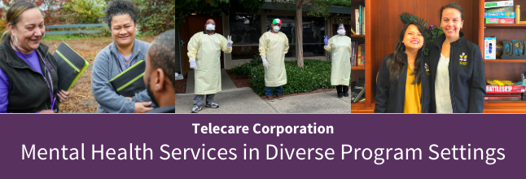

Drug and Alcohol Counselor, RADT Entry Level (All Shifts) #386
Telecare's mission is to deliver excellent and effective behavioral health services that engage individuals with complex needs in recovering their health, hopes, and dreams. Telecare has over 170 programs and 4,500 employees across the country.
Telecare is thrilled to have been selected to provide four (4) different substance use treatment services (SUTS) programs at The Be Well, OC Campus at 265 S. Anita Drive in Orange, CA.
No single entity can solve the ongoing challenges of mental health and substance use disorders alone. However, by partnering with multiple local healthcare entities and organizations, Orange County has created The Be Well campus, which pulls together multiple levels of care in one location, under one license, in an intentionally coordinated system.
The beautiful location and peaceful space support a respectful, healing environment. People can move into different levels of care as needed to provide a smooth and supportive recovery experience. The campus serves people who have commercial insurance as well as those who have Medi-Cal, to provide services to our entire community under one roof.
Available Shifts
Day Shift 7:00 AM – 3:30 PM
Swing Shift 3:00 PM – 11:30 PM, comes with a 6% Shift Differential
Overnight 11:00 PM –7:30 AM, comes with an 8% Shift Differential
Per Diem / On-Call
What We Provide!
- Free Supervision Hours toward your independent SUD Certification and License
- Training, Coaching, and Mentorship
- Career growth potential
- Want to learn the competencies and nuances of public mental health? We are ready to teach you!
What are the qualifications? (Must Have)
- Registered Alcohol and Drug Technician (RADT) Certification Required
- High school diploma or GED. (Associate or Bachelors' degree preferred)
- Knowledge of the needs of individuals diagnosed with co-occurring disorders and substance abuse
- Must have CA Driver's License that is valid and current
- Maintain active status of certification and continuing education as required by licensing board
- Within the first (2) months of employment, the ability to learn basic billing requirements and codes
- Focus and passion for providing excellent customer service
What will the job entail?
- Conducts admissions, intakes, and discharge planning in support of client flow
- Provides specialized services and interventions related to substance use/addictive disorders, including thematic groups, evidence-based practices, and collaboration with external agencies and resources
- Attends and participates in community meetings and groups
- Helps create a recovery environment through interactions with staff and members served
- Demonstrates knowledge of management of assaultive behavior techniques
- Responds to emergencies
- Assists and advocates for members served in obtaining appropriate benefits
- Assists with outings for members done by driving Program van and own vehicle
What is your Total Rewards Compensation?
- Low-cost health insurance options: Medical, Vision, Dental
- Paid time off pool starting at 16.7 days (over 3 weeks) in your first year
- Eight paid holidays per year
- Two retirement plans: 401K & Employee Stock Ownership Plan (ESOP)
- Online University Tuition Discount
- Scholarships
- Enjoy other benefits, including career growth, learning opportunities, and recognition.
- Some benefits may vary based on the location and full-time or part-time employees.
All opportunities at Telecare are contingent upon successful completion and receipt of acceptable results of the post-offer physical examination, 2-step PPD. Test for tuberculosis, acceptable criminal background clearances, excluded party sanctions, and degree or license verification. If the position requires driving, a valid driver's license, a motor vehicle clearance, and proof of auto insurance are required at the time of employment and throughout your job. Be CPR, Crisis Prevention Institute (CPI), and First Aid certified on hire date or within 60 days of work and maintain current certification throughout the job.
We are building a multidisciplinary, multiethnic, multi-generational, and multicultural team.
When you work at Telecare, you help empower thousands of individuals every day in their recovery journeys. We are looking for compassionate, hardworking, focused, organized mental health workers to serve our clients with severe and persistent mental illness. Website: https://tinyurl.com/ycy7bnnf
Telecare's Official Job Title for this role: SUTS Coordinator
EOE AA M/F/V/Disability

